**Use traceroute to identify where the packets are being dropped if the ping fails.**

**Pinging the Linux machine from Windows**

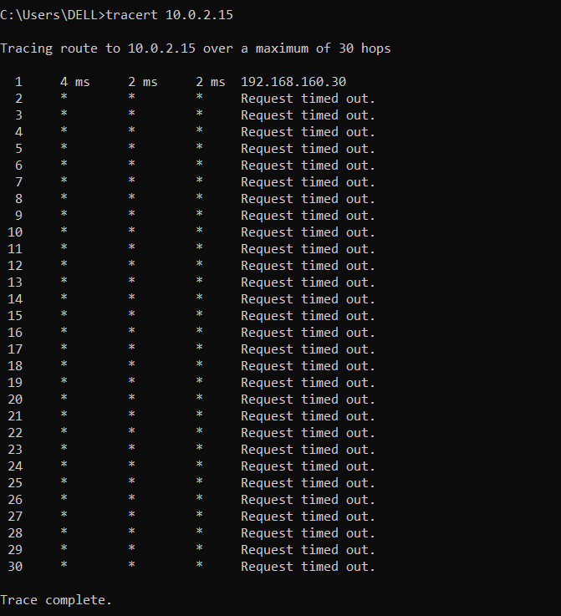

**Observation:**

* I tried to ping my Linux VM (10.0.2.15) from my Windows machine (192.168.160.30), but it timed out. I was able to ping Windows from Linux.
* To check what was wrong, I ran tracert 10.0.2.15 in Windows. The packets reached the first hop (192.168.160.30) but timed out after that.
* This happened because my Linux VM was using NAT in VirtualBox. NAT doesn’t allow incoming connections from the host by default, so Windows couldn’t reach Linux.
* Also, ICMP requests might be blocked in Linux, which could stop the ping replies even if the network was reachable.
* To fix this, I can either change the network adapter to Bridged mode so both machines are on the same network or set up port forwarding in VirtualBox NAT settings to allow ICMP packets to reach Linux.